February 2019
Vision: the heart of Woodchester School – Parent responses
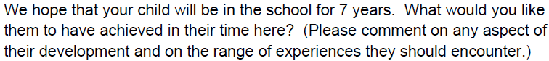

Gained an all-round experience, not only from an educational stand point but an emotional gain with their peers – making friends, sharing experiences, as well as an introduction into their physical wellbeing.
To become a good, kind and respectful person
To be happy, caring, have a positive attitude. Have achieved excellent results to the best of their ability
That they are happy.
To have achieved their potential and be inspired by what they have learnt. To have plenty of ‘memorable experiences: Young Voices, Shakespeare plays, sporting events
To realise their individual potential and be prepared for secondary school
To play a musical instrument. To obtain high results in all areas. To achieve emotionally, socially and in education.
To leave with a positive sense of self. To have good manners and to know that they can achieve whatever they set their hearts on.
To develop in line with their age, academically. To make good friends. To be happy and confident at the end of their time here.
To feel safe and supported emotionally and academically. Promote, encourage, nurture any talents my daughter might have. To be confident and have the ability to form different relationships. To have a positive school experience.
Identifying strengths; resilience; understanding the range of learning styles; confidence in questioning; beginnings/foundations for critical thinking.
Confidence, great social skills, competency in all subjects, have interest in music, drama and art
To develop not only academic skills but also social skills and resilience. To develop in sports and the arts, as well as get involved in her community.
A passion for learning and lots of opportunities to participate in a wide variety of activities.
Achieving his full potential/being able to solve problems and be resourceful/having a well-rounded education/spring board for strong secondary education/having self-belief and confidence in himself and his ability
A love of learning, confident in his own abilities, emotionally resilient, a sense of social responsibility, a creative thinker.
Look back fondly at their time/ be happy, confident, compassionate, resilient, able to rationalise and think critically, especially in an era of fake news and social media

February 2019
Vision: the heart of Woodchester School – Parent responses

It is a close knit community with involvement from parents as well as teachers.
Interaction between younger and older children is generally good.
Positive attitude, kind and caring, good curriculum, Christian values, happy atmosphere
It is very caring
Open, friendly, well organised, with an important focus on core values
Family atmosphere, small enough to feel like a family
Parents and staff seem welcoming and helpful
Bright, happy, enthusiastic, passionate about learning.
Community, lovely parents/children/very good and welcoming teachers/staff
Small village school which stands strong and achieves excellent results
Traditional, conservative, Christian, sits in the heart of a village community that is creative, productive, engaged, friendly and welcoming
The staff, the location
There is a good cohesion between children and teachers
It is warm, nurturing and safe school for children
Community spirit/safe environment/high standards/committed staff and Headteacher
Welcoming, caring, a community that crosses the whole school
A nurturing environment where each child is understood and valued

February 2019
Vision: the heart of Woodchester School – Parent responses
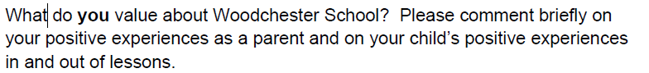

The opportunities to experience any things – forest school, P.E. activities, swimming, mini marines, ? of the curriculum.
Approachability and togetherness
Positive attitude, kind and caring, good curriculum Christian values happy atmosphere
My child is very happy at school
The friendliness of school/the progress my child has made through great teaching/the ‘extra’ experiences – Shakespeare plays, focus weeks, sports events/my son has never been unhappy
Music and the way the school accommodates it/academic achievement and progress/positive relationships/emotional wellbeing and resilience
Sense of belonging and community feel/my daughter is happy and enjoys sports and lessons
I believe we are an outstanding school because we go above and beyond to ive our children the tools that help them to shine
Small village school, happy environment
Polite and respectful/all children happy to play and interact regardless of age/my daughter has received a warm welcome from staff and pupils
Location – in the heart of the community / dedicated, professional and friendly staff/ great trips – Young voices, PGL
Support and flexibility of the staff and how informed we are as parents/also the proactive PTA
Teachers seem engaged in teaching the WHOLE child, from academic to social skills. I also like the emphasis on sports and the arts.
The way the teachers talk to and show respect to the children. The way that children are encouraged to try lots of new experiences
X enjoys school and his friendships/staff are experienced, committed and approachable/small school- community spirit
It is part of the wider Woodchester community, it provides a balanced curriculum and has a holistic approach to children’s development
A very caring atmosphere/older children at sports dy taking care of younger ones/my child’s interests are recognised by staff and m child is encouraged to develop at their own pace

February 2019
Vision: the heart of Woodchester School – Parent responses
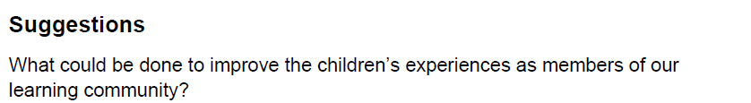

More special/unusual experiences to bring work alive e.g. links with a 3rd world school/more trips/more outreach links to Woodchester Mansion (History, English)
With continuity in leadership which has been lacking until Mrs Pennington arrived hopefully progress can be made to carry out better what it does already.
Breakfast clubs/French and musical instrument from Reception
Focus on the child’s interest and a topic which fascinates them, which will empower them
Better access to ICT learning and hardware/more and wider access to creativity/engaging in the wider village – community and environment/learning about their wider community – Stroud, Glos + Uk/learning about diversity
Getting more involved in the wider community, perhaps with local charity or projects
Field trips?
To continue to ensure balance of gender in the children’s learning experience

Suggestions
Putting out timings to sign up for e.g. reading, etc.
Subject focus evening for Core subjects particularly maths and English/parental lack of knowledge on methods of teaching and grammar
More discussion with parents around behavioural expectations in and out of school
Get them involved with as much work and events as possible/send out helpful learning/support tips to move children along
To invite parents into school to talk about their occupation/profession to pupils
Greater opportunities for involvement, discussion and communication
More consideration of working parents and demand there upon. Better communication of opportunities rather than word of mouth in playground
The open classroom has been welcome and class dojo is very well used by Mrs Loomes
Nothing in our opinion

